HR DATA DASHBOARD

Power BI Project

SANJANA DALVI

**Index**

1. **Introduction**

* Introduction to the Dataset
* Objective of the Analysis and Dashboard Creation

1. **Data Sources**
   * Source Description
   * Data Extraction Process
   * Data Quality and Preparation
2. **Data Model**
   * Schema Design
   * Relationships
   * Data Transformation
3. **Visualizations**
   * Dashboard Design
   * Key Metrics and KPIs
   * Interactive Elements
4. **Conclusion**
   * Summary of Results

**Introduction to the Dataset**

**Dataset Information:**

* The dataset used for this dashboard includes employee details such as job role, salary, performance ratings, and demographics.
* It contains data for 1470 employees with various metrics like monthly income, hourly rate, business travel frequency, marital status, and education field.
* The data was sourced from the company's HR database to help in decision-making by analyzing workforce trends and performance.

The HR Data Dashboard is designed to provide key insights into employee performance, compensation, and workforce demographics. It helps HR managers track metrics such as employee count, age, performance ratings, monthly income, and salary hikes.

**Objectives of the Analysis and Dashboard Creation**

The primary objectives of the dashboard are to:

* **Monitor Employee Performance**: Evaluate the performance ratings across different job roles.
* **Track Employee Compensation**: Analyze monthly income, hourly rates, and salary hikes based on job role and department.
* **Understand Workforce Demographics**: Provide insights into employee age distribution, gender, and marital status.
* **Evaluate Business Travel Patterns**: Understand travel frequencies across the organization.

**Data Sources and Preparation**

**Source Description**

The HR dataset is sourced from a comprehensive collection of transactional data across various business units. This dashboard pulls data from HR management systems, including records of:

* **Employee personal details** (age, gender, marital status)
* **Job roles** and their corresponding metrics (monthly income, performance ratings, etc.)
* **Compensation and salary hikes** across various education fields.

**Data Extraction Process**

The data extraction process involves several key steps to ensure that the dataset is accurately and efficiently gathered from its sources:

1. **Data Collection**: Data is retrieved from various sources such as sales databases, CRM systems, and logistics platforms. This involves exporting data files (e.g., CSV, Excel) or connecting to databases via queries.
2. **Data Consolidation**: Extracted data is consolidated into a single repository to facilitate analysis. This may involve merging files from different sources and ensuring that all relevant fields are included.
3. **Data Validation**: Initial checks are performed to ensure that the extracted data is complete and accurate. This includes verifying that all necessary fields are present and that the data adheres to predefined formats and standards.
4. **Data Integration**: Data from different pages or sources is integrated into a unified format suitable for analysis. This includes aligning data structures and ensuring consistency across the dataset.

**Data Quality and Preparation**

Ensuring high data quality and preparing it for analysis involves several critical steps:

1. **Data Cleaning**: Identifying and rectifying errors or inconsistencies in the dataset. This includes handling missing values, correcting incorrect entries, and removing duplicates.
2. **Data Transformation**: Converting raw data into a format suitable for analysis. This involves normalizing values, creating derived fields (e.g., calculating total sales), and categorizing data (e.g., segmenting customers).
3. **Data Validation**: Performing further checks to ensure the accuracy and reliability of the data. This involves comparing data against source records, conducting consistency checks, and validating calculations.

**Data Model**

The data model represents the structure and relationships between the tables in the HR dataset. It captures various employee attributes such as job roles, compensation, performance ratings, demographics, and business travel information.

**Entities in the Data Model**

The data model will primarily consist of the following entities (tables):

**A. Employee Table**

* **Description**: This table holds the personal and demographic information about each employee.
* **Columns**:
  + EmployeeID: Primary key, unique identifier for each employee.
  + FirstName: Employee's first name.
  + LastName: Employee's last name.
  + Age: Employee's age.
  + Gender: Gender of the employee.
  + MaritalStatus: Employee's marital status (Married, Single, Divorced).
  + Department: Department in which the employee works (e.g., Sales, R&D).
  + JobRole: Employee’s job role in the company (e.g., Manager, Sales Executive).
  + EducationField: Employee’s field of education (e.g., Life Sciences, Technical Degree).
  + BusinessTravel: Business travel frequency of the employee (e.g., Non-Travel, Travel_Rarely, Travel_Frequently).

**B. Compensation Table**

* **Description**: This table contains salary, hourly rate, and income details.
* **Columns**:
  + EmployeeID: Foreign key linking to the Employee table.
  + HourlyRate: Hourly compensation for the employee.
  + MonthlyIncome: Monthly salary received by the employee.
  + PercentSalaryHike: Percentage increase in salary during the last appraisal.

**C. Performance Table**

* **Description**: This table holds employee performance-related data.
* **Columns**:
  + EmployeeID: Foreign key linking to the Employee table.
  + PerformanceRating: Performance rating of the employee (e.g., from 1 to 5).
  + LastPromotionDate: Date of the employee's last promotion.
  + YearsAtCompany: Number of years the employee has worked in the company.
  + StandardHours: Standard hours worked by the employee (fixed at 40 hours per week).

**Data Flow and Usage in the Dashboard**

1. **Performance Rating by Job Role:**
   * Data is drawn from the Employee and Performance tables.
   * Performance ratings are grouped by job roles using the Job Role table.
2. **Employee Age Distribution:**
   * Age data from the Employee table is used to create a histogram.
3. **Monthly Income by Job Role and Department:**
   * Data is drawn from the Compensation, Employee, Job Role, and Department tables.
   * Monthly income is aggregated by job roles and departments to display income trends.
4. **Percent Salary Hike by Education Field:**
   * Data is aggregated from the Employee and Compensation tables to show salary hikes based on education fields.
5. **Hourly Rate by Job Role:**
   * Data is drawn from the Compensation and Job Role tables to display hourly rates for different roles.

**Data Transformation**

1. **Data Cleansing:** Handling missing values, removing duplicates, and detecting outliers in variables like MonthlyIncome and HourlyRate.
2. **Normalization:** Scaling numeric columns and encoding categorical variables like Gender and MaritalStatus.
3. **Aggregation:** Summarizing data by JobRole, Department, or EducationField to calculate metrics like average income, performance ratings, and salary hikes.
4. **Filtering:** Applying filters to segment data based on gender, travel frequency, or marital status for more focused insights.
5. **Mapping & Calculated Columns:** Assign numeric values to categorical data and create new columns, e.g., IncomePerHour for detailed analysis.
6. **Data Joins:** Combining multiple tables (e.g., Employee and JobRole) to create a unified dataset.
7. **Time-Series Analysis:** Transforming date fields for trend analysis, like salary hikes over time.

**Visualization**

**Dashboard Design**

1. **Layout and Structure**: Design a clear and intuitive layout. Use a grid system to organize content, ensuring that the most important information is prominently displayed.
2. **Color Scheme**: Choose a color palette that is both visually appealing and functional. Ensure that colors are used consistently to represent the same type of data across different charts.
3. **Data Storytelling**: Arrange elements to guide the user through the data story. Start with high-level metrics and allow users to drill down into more detailed data.

**Key Metrics**

* **Employee Count:** 1470 employees**.**
* **Average Age:** 36.92 years.
* **Performance Rating:** Performance distribution by job role**.**
* **Monthly Income:** Analysis by job role and department**.**
* **Salary Hike:** Percent salary hike based on education field.

**5. Key Insights**

* Sales Executives and Research Scientists have the highest performance ratings.
* Managers and Healthcare roles receive the highest average monthly income.
* Employees with technical and life sciences education receive higher salary hikes.
* Majority of employees are non-frequent travelers, indicating potential travel cost reductions.

**Interactive Elements**

1. **Filters**: Allow users to filter data by different dimensions such as time period, region, or product category.
2. **Drill-Downs**: Enable users to click on summary metrics to view more detailed breakdowns or related data.
3. **Tooltips**: Provide additional context or explanations for data points when users hover over or click on them.
4. **Dynamic Charts**: Use charts that update in real-time based on user selections or interactions, helping to explore different scenarios or trends.

**Dashboard Overview**

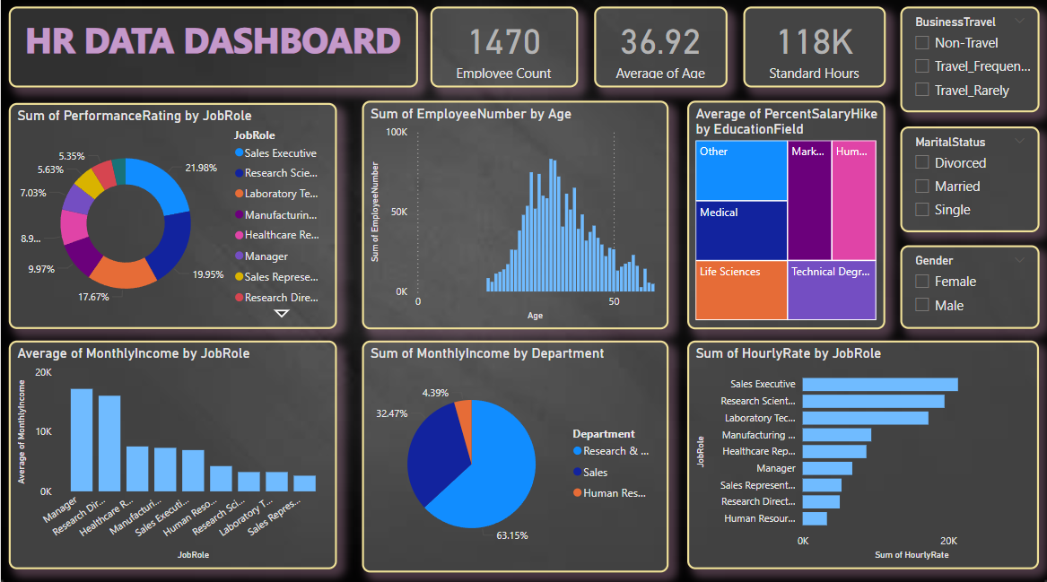

**Key Metrics and Insights**

* Employee Count: A total of 1470 employees are represented.
* Age Distribution: The average age is 36.92 years, and the age distribution is presented in a histogram.
* Standard Hours Worked: 118K hours worked across all employees.
* Business Travel Patterns: The dashboard divides business travel into three categories—Non-Travel, Travel_Frequently, and Travel_Rarely.
* Marital Status: Distribution of employees into Divorced, Married, and Single categories.

**Performance Analysis**

* Sum of Performance Ratings by Job Role:
  + The highest percentage of performance ratings is in the Sales Executive role (21.98%).
  + Research Scientists follow closely with 19.95%.
  + Performance across various other roles is analyzed in a pie chart.

**Departmental Compensation Analysis**

* Sum of Monthly Income by Department:
  + Research and Development commands the highest percentage of total monthly income, at 63.15%.
  + Other departments like Sales and Human Resources are represented with smaller shares.

**Salary Hike Trends**

* Average Percent Salary Hike by Education Field:
  + Employees with a Technical Degree and Life Sciences education receive the highest average salary hikes.
  + Fields such as Medical and Marketing show moderate hikes.

**Hourly Rate Analysis**

* Sum of Hourly Rate by Job Role:
  + Sales Executives and Research Scientists have the highest hourly rates.
  + Roles like Laboratory Technician and Manufacturing Director also show significant hourly earnings.

**Demographic Insights**

* Employee Age Distribution:
  + The age distribution is centered around the 35-45 year range, with a significant number of employees under 50.

**Employee Breakdown by Marital Status and Gender**

* **Marital Status:**
  + The majority of employees are Married, followed by Single and Divorced categories.
* **Gender Distribution:**
  + Gender breakdown is visually represented for further analysis.

**Business Travel Insights**

* Business Travel Categories:
  + Most employees are categorized as Non-Travelers, with a smaller segment that travels frequently.

**Conclusion**

This HR dashboard provides a comprehensive overview of key employee metrics such as performance, compensation, demographics, and workforce characteristics. By utilizing various data visualizations, it enables stakeholders to easily analyze and compare important HR statistics across departments, job roles, and other relevant factors.

Key insights from the dashboard include:

* **Employee Composition**: The majority of employees fall within the 30-40 age range, indicating a mid-career workforce.
* **Performance and Compensation**: Sales Executives and Research Scientists are highlighted as top performers, while Managers and Research Directors receive the highest average monthly incomes, suggesting a correlation between leadership roles and compensation.
* **Departmental Contributions**: The Research & Development department contributes the largest share of total monthly income, emphasizing its critical role in the organization.
* **Salary Growth**: Employees in Technical and Life Sciences fields show significant salary hikes, highlighting the importance of education in career growth.

The use of interactive filters allows for a deeper, more personalized exploration of the data, such as analyzing differences in performance or income based on gender, marital status, or travel frequency.

**Impact and Future Scope:**

The dashboard provides actionable insights that can assist HR managers in making informed decisions regarding promotions, salary adjustments, and workforce planning. In the future, the dashboard can be expanded by incorporating more dynamic data (e.g., employee tenure, turnover rates) and predictive analytics to forecast workforce trends and employee satisfaction. Additionally, more advanced drill-down capabilities can be added to allow for more detailed, role-specific analysis.

**Thank You**